**RC BLUE App Documentation**

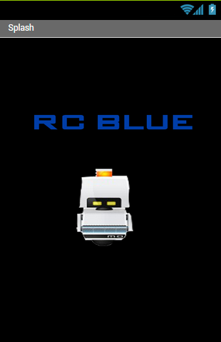

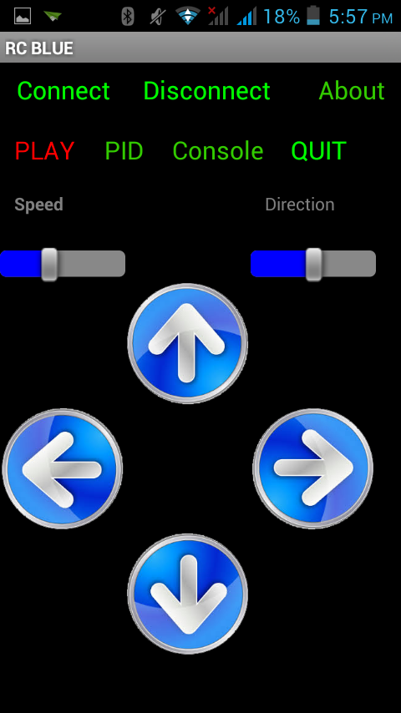 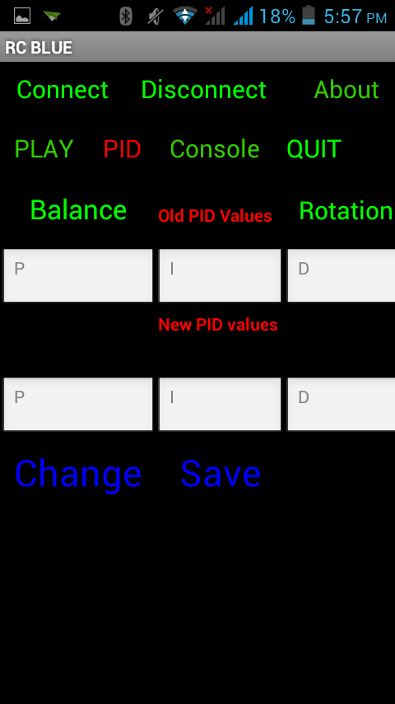

Images of App

The App consists of 2 separate screens-

1. Splash
2. Main

**Splash Screen**

Splash screen as name implies displays splash image for 1 sec and then move to Main screen.

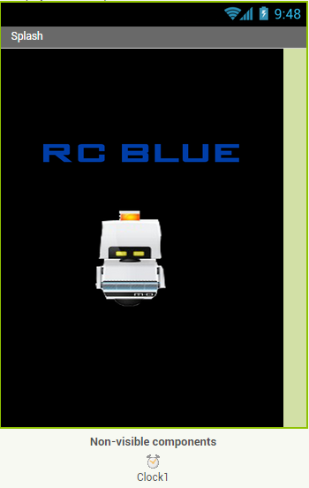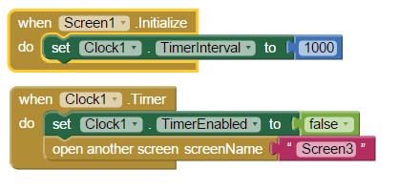

A timer is set to 1 sec. When it goes off, Screen3 (main) will open.

**Main screen**

Main screen contains all the program.

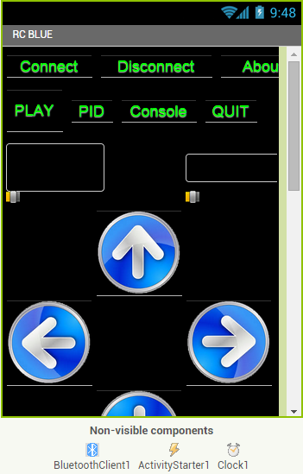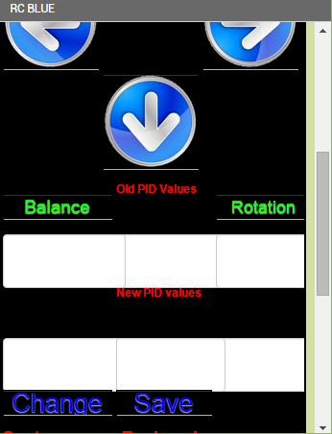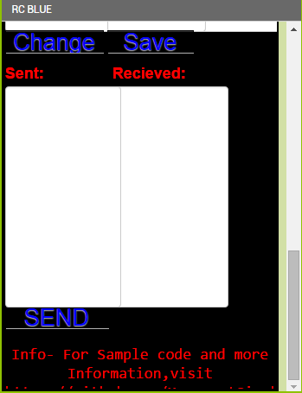

Above Images shows the Design of main screen. Main screen has 3 non-visible components-

* BluetoothClient
* ActivityStarter
* Clock

BluetoothClient is for Bluetooth connection, ActivityStarter is enable Bluetooth if not already enabled and clock is used as timer.

Main screen is divided into following parts for better understanding.

1. **Screen**

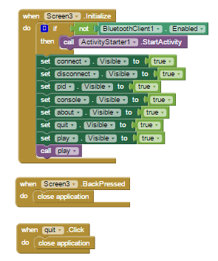

On initialize, if Bluetooth is not enabled, it will start activity to enable it. It set menu to visible and by default load the play options.

1. **Bluetooth**

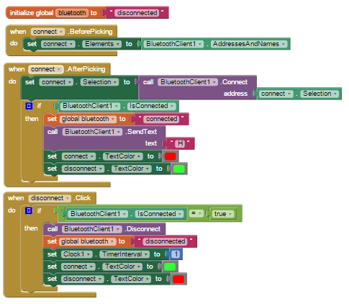

Initialize global Bluetooth variable to *disconnected*. A listpicker named connect is used to first select Bluetooth device. After picking, connect to device and set bluetooth to *connected*.

On clicking *disconnect*, disconnect Bluetooth device if connected and set Bluetooth to *disconnected.*

1. **Menu**

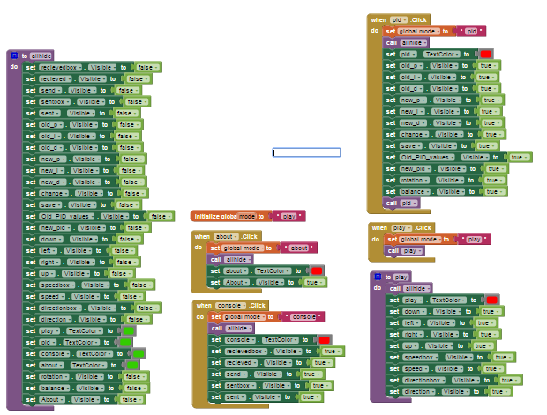

By default, *play* mode is selected. On clicking a mode, all contents of other mode will be hidden by *allhide* procedure and only the content of current mode will be shown.

1. **Play**

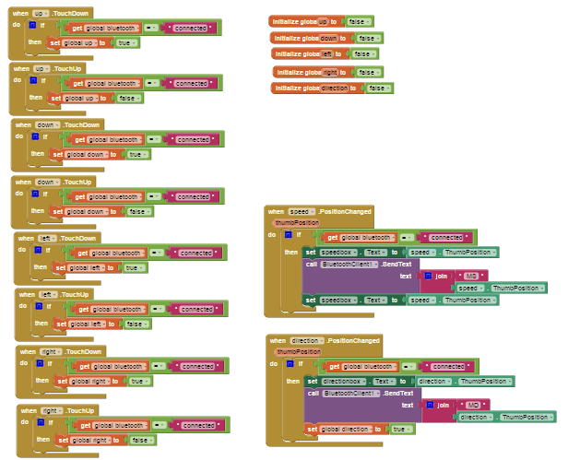

On holding any of the four buttons-*up,down,left,right, it* will set corresponding variables to true until hold. These variables are further used in timer to send message through Bluetooth.

On changing of *speed, direction* slider, it will send its position through Bluetooth using appropriate headers.

1. **Console**

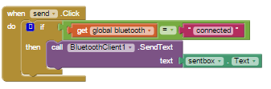

When send is clicked, it will send whatever is in the sentbox through Bluetooth.

1. **Timer**

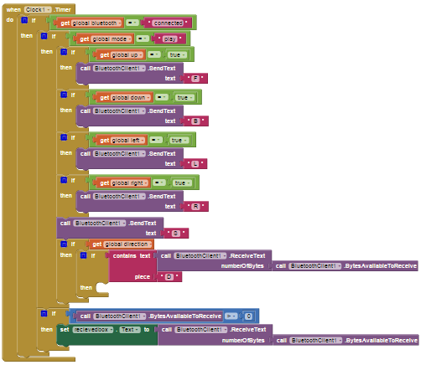

In each interval, if *up,down,left,right* is true, it will send *F,B.L,R.*

If there is any incoming message, it will be placed in receivedbox.

1. **Pid**

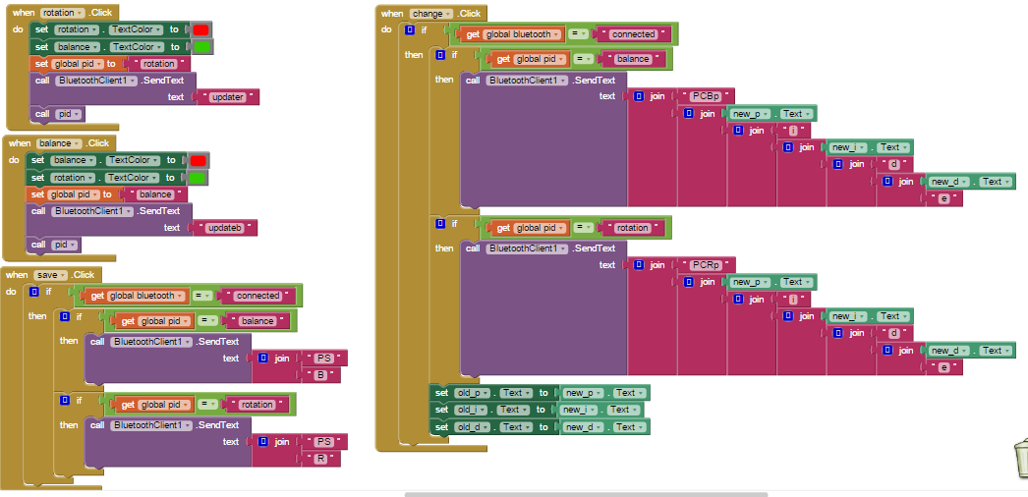

In Pid mode, if *rotation* is clicked, *updater* is sent and if balance is clicked, *updateb* is sent and then pid procedure is called.

On clicking *save,* if pid is set to *balance, PSB* is sent and if pid is set to *rotation, PSR* is sent.

On clicking *change*, depending on pid variable, new pid values are sent in appropriate format and new pid values are copied to the old pid value boxes.

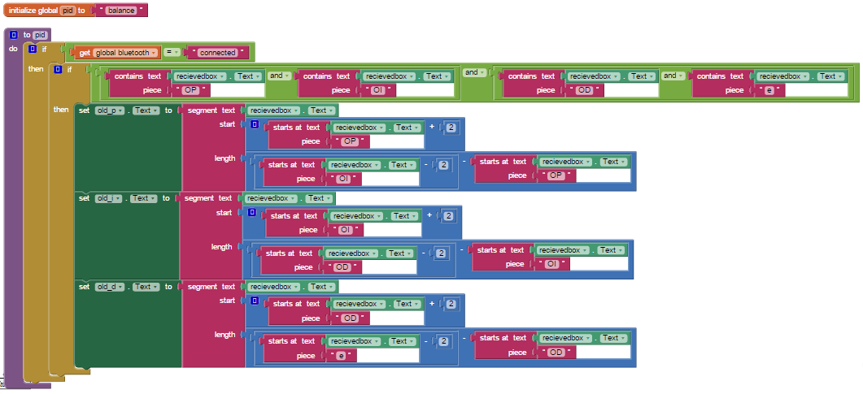

In above pid procedure, if recievedbox has received old pid value from Bluetooth in suitable format, they will be updated in app.